the steps to install WordPress on an Ubuntu-based Azure Virtual Machine:

**Prerequisites:**

1. Azure subscription.
2. Basic knowledge of Azure Virtual Machines and WordPress.

**Step-by-Step Installation:**

1. **Create an Azure Virtual Machine with Ubuntu:**
   * Log in to the Azure portal (portal.azure.com).

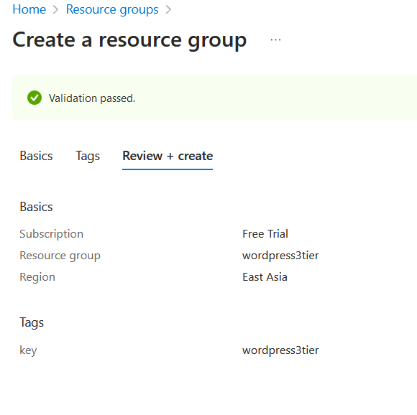

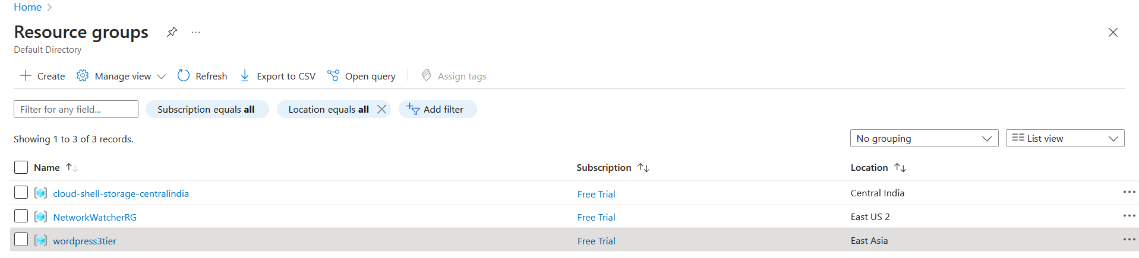

* + Click on "Create a resource" > "Compute" > "Virtual Machine".
  + Fill in the required details such as VM name, region, resource group, and VM size.

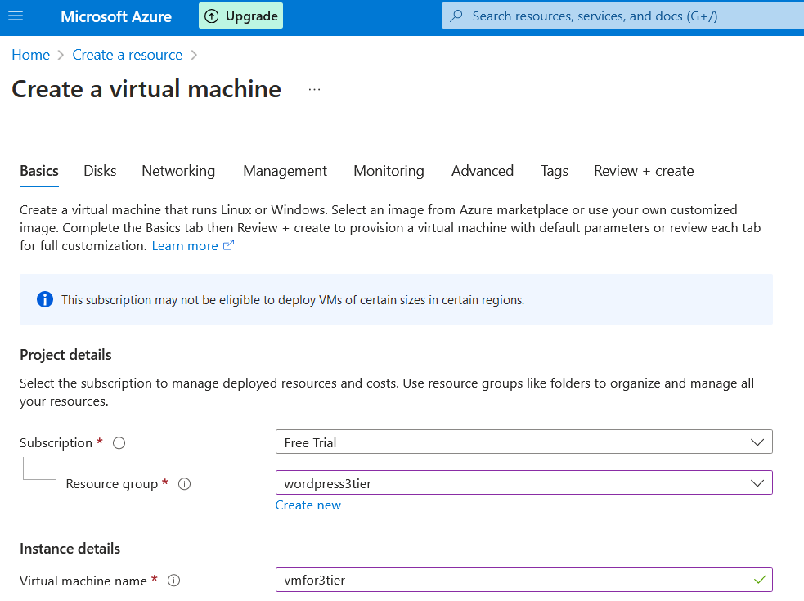

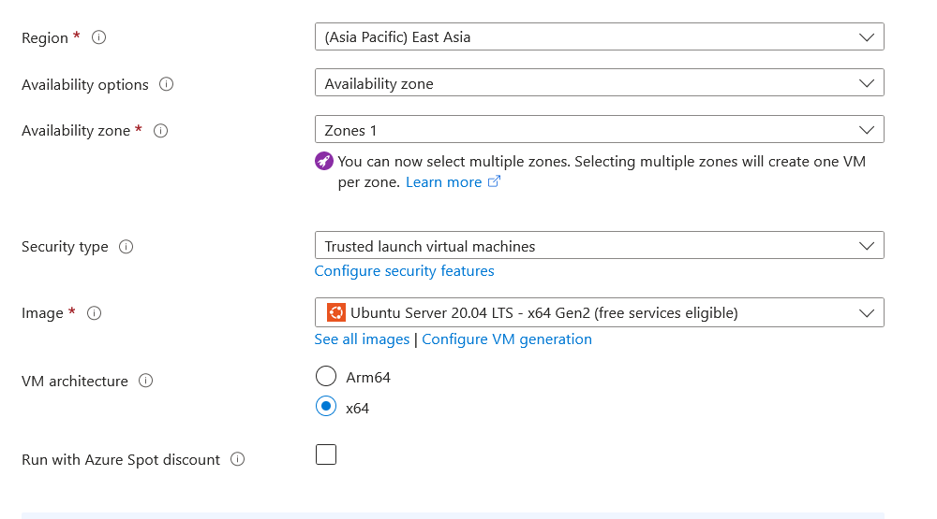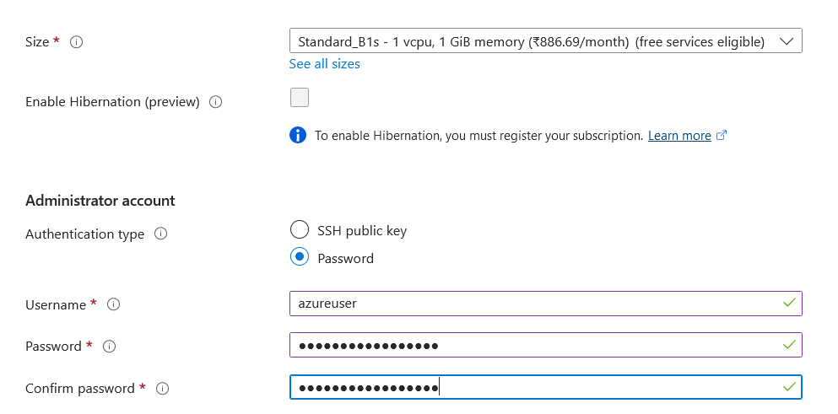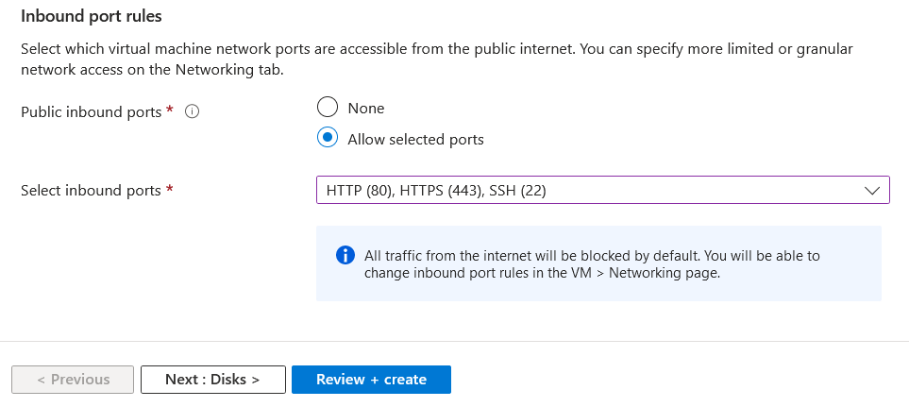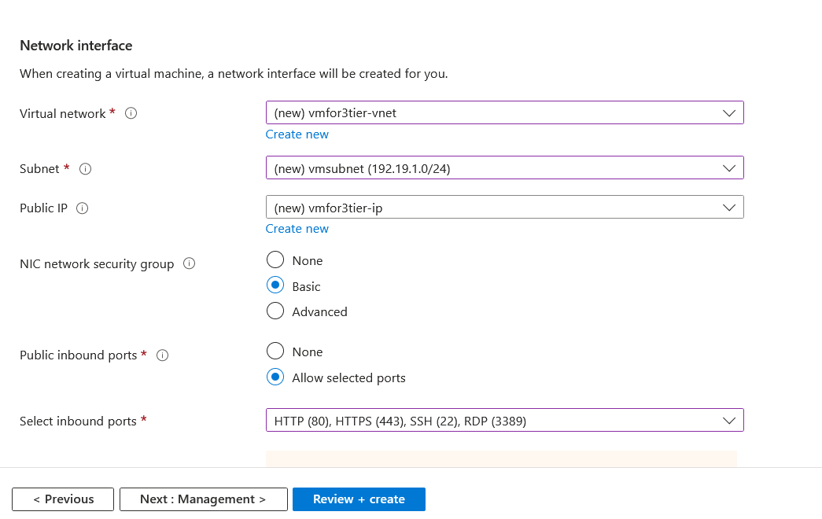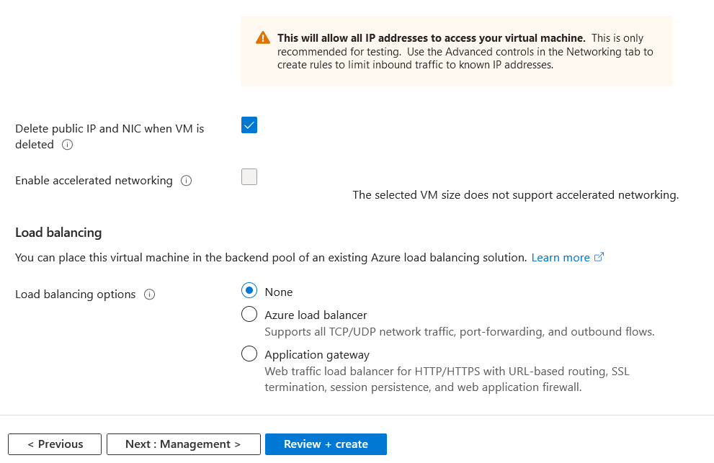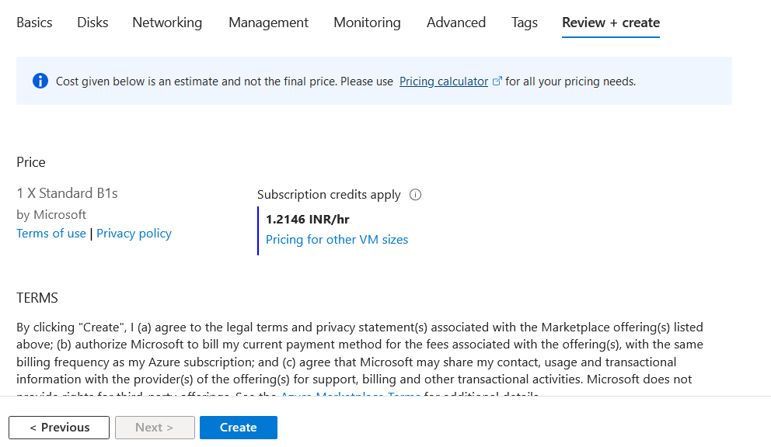

* + Choose "Ubuntu Server" as the operating system image for your VM.
  + Configure networking settings, including virtual network, subnet, public IP address (if needed), and network security group.

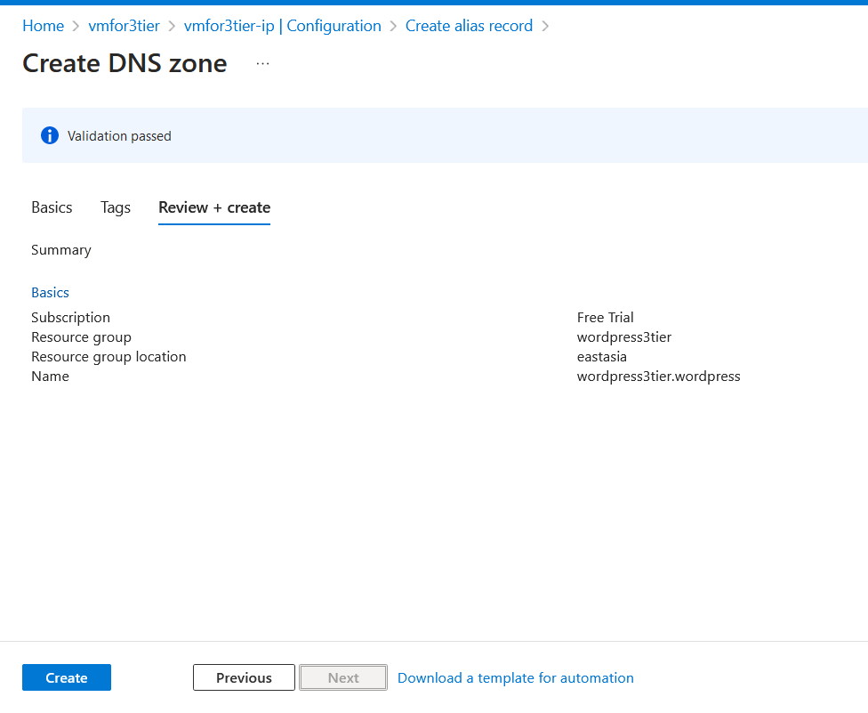

1. **Connect to the Ubuntu VM:**
   * Once the VM is created, connect to it using SSH.

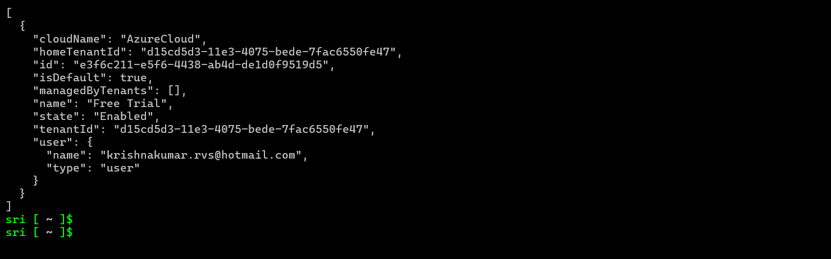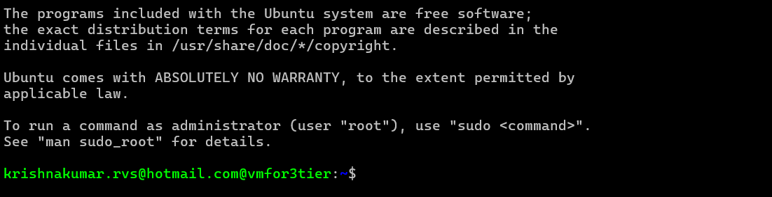

* + Use an SSH client like PuTTY (for Windows) or the terminal (for Linux/macOS) to connect to the VM.
  + Use the username and SSH key specified during the VM creation process to log in to the VM.

1. **Install LAMP Stack:**
   * Update the package index on your Ubuntu server: sudo apt update.

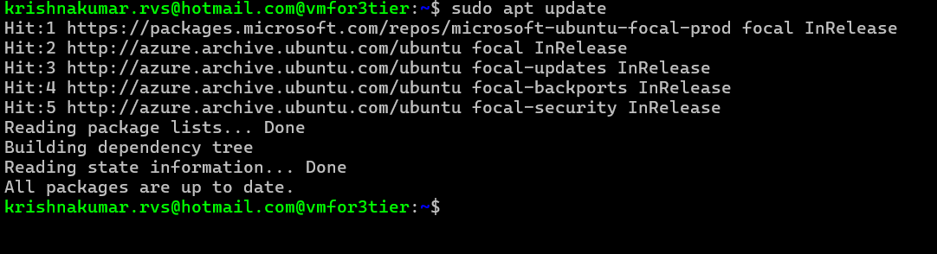

* + Install Apache, MySQL, and PHP:

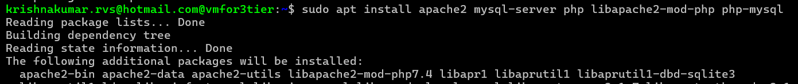

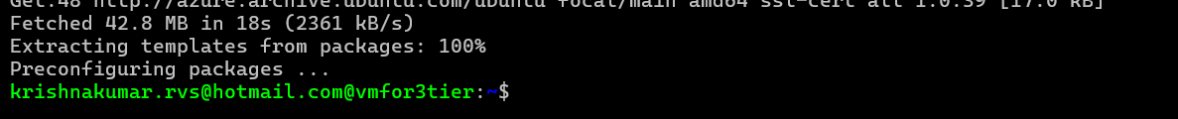

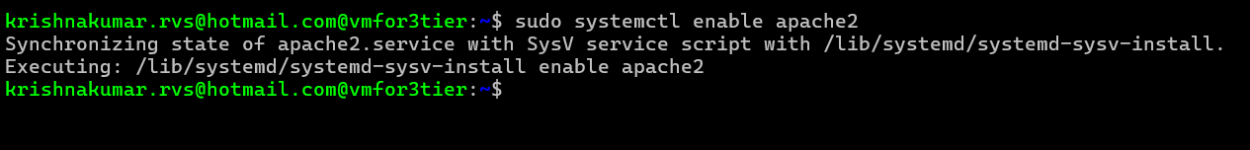

bash

* •
* sudo apt install apache2 mysql-server php php-mysql
* sudo systemctl enable apache2
* sudo systemctl start apache2
* sudo systemctl enable mysql

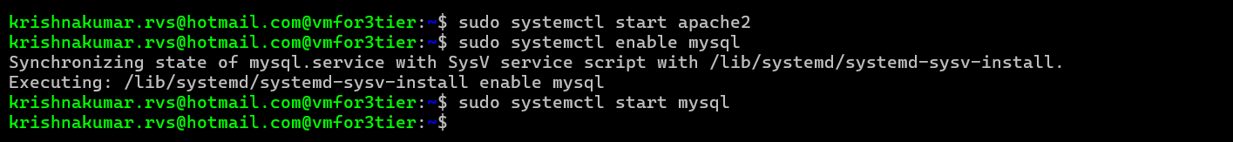• **Secure MySQL Installation:**

* Run the MySQL secure installation script: sudo mysql_secure_installation.
* Follow the prompts to set a root password, remove anonymous users, disallow remote root login, and remove the test database.

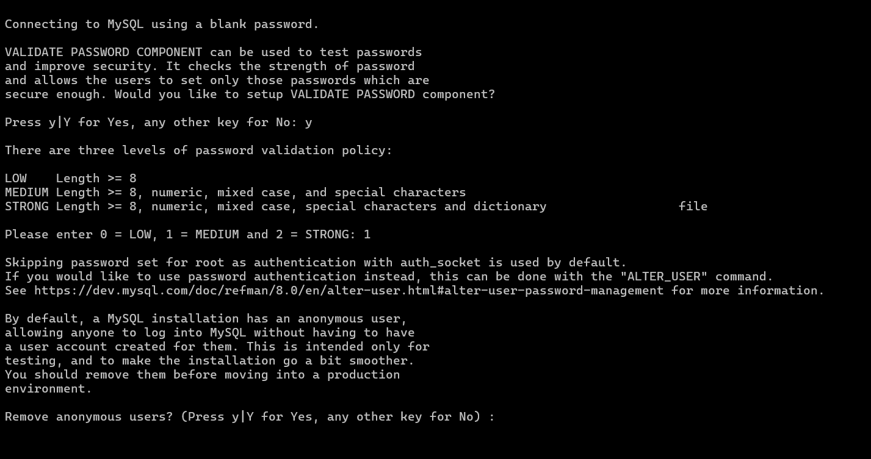 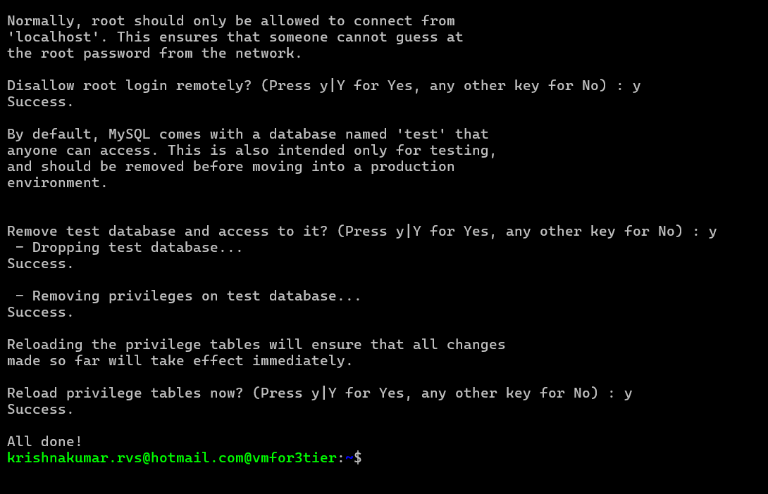

• **Create a MySQL Database and User for WordPress:**

* Log in to MySQL as the root user: sudo mysql -u root -p.

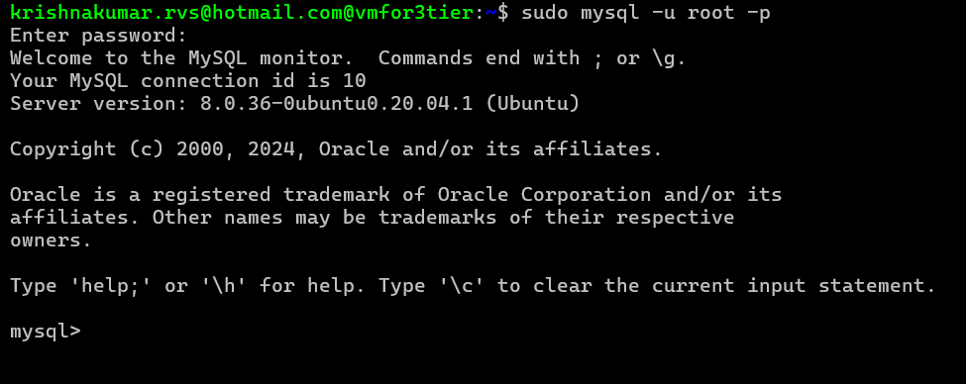

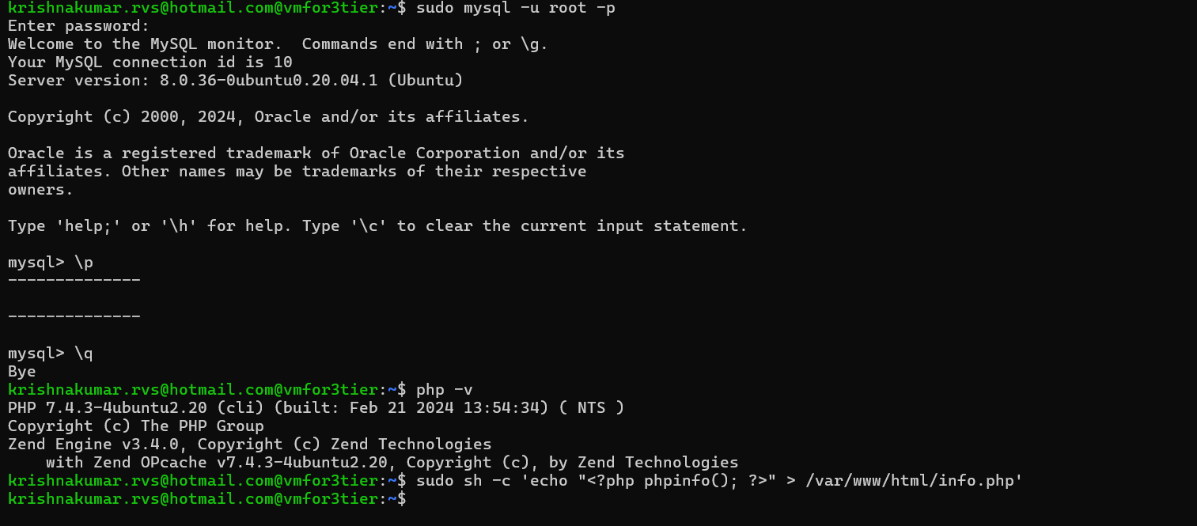

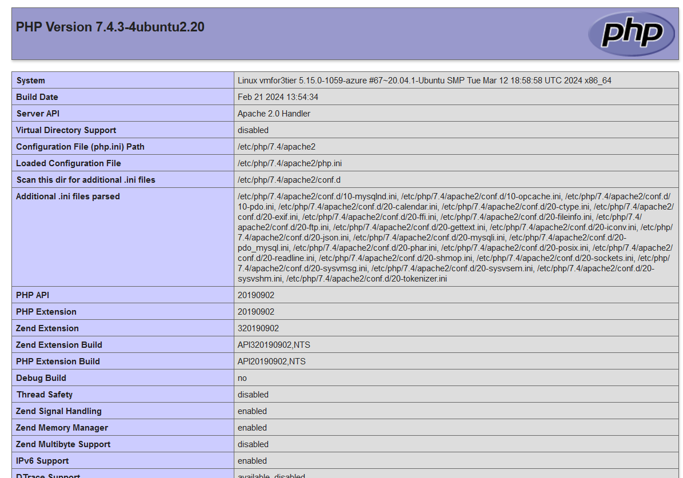

* Create a new database for WordPress: CREATE DATABASE wordpress;.



* Create a new user and grant privileges to the WordPress database:

CREATE USER 'wordpressuser'@'localhost' IDENTIFIED BY 'password'; 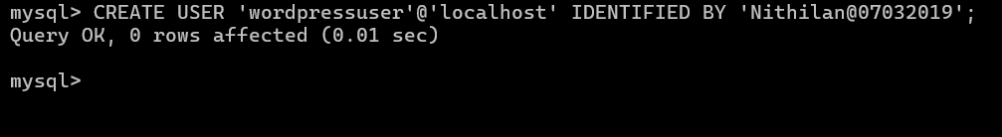

sql

* •
* GRANT ALL PRIVILEGES ON wordpress.* TO 'wordpressuser'@'localhost';

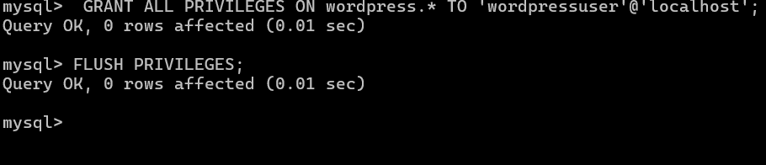• **Install WordPress:**

* Download the latest WordPress release and extract it:

arduino

• • Move the extracted WordPress files to the Apache web root directory: 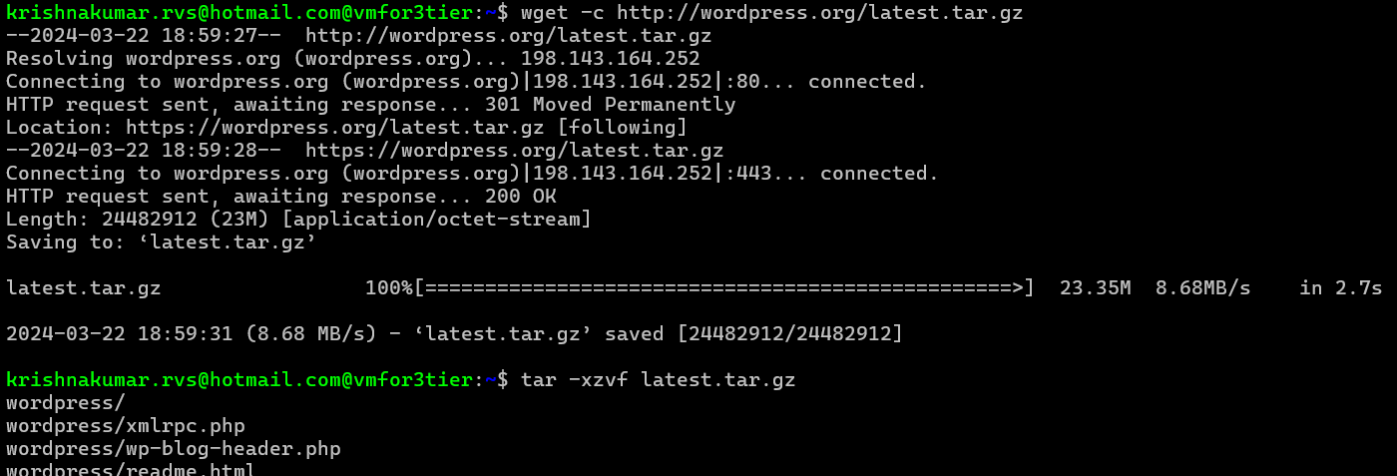

bash

• 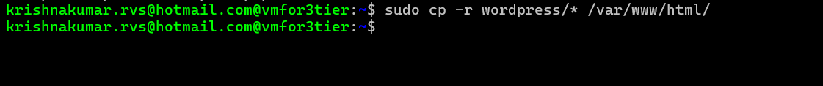

• Set the correct permissions for the WordPress files:

bash

* • 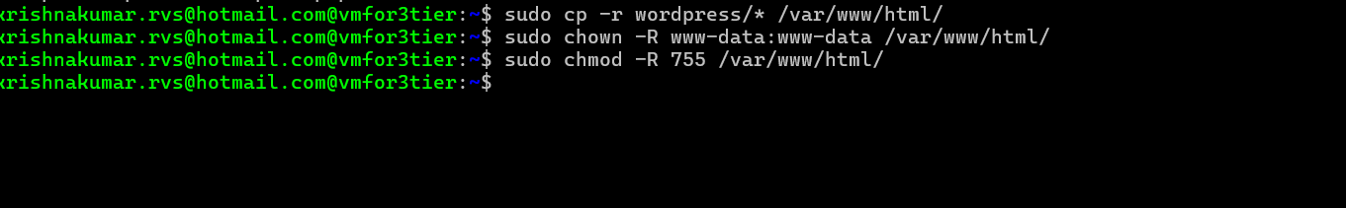
* sudo chown -R www-data:www-data /var/www/html/
* sudo chmod -R 755 /var/www/html/

• **Configure WordPress:**

* Create a configuration file for WordPress based on the sample provided:

css

* + sudo cp /var/www/html/wp-config-sample.php /var/www/html/wp-config.php
  + sudo nano /var/www/html/wp-config.php



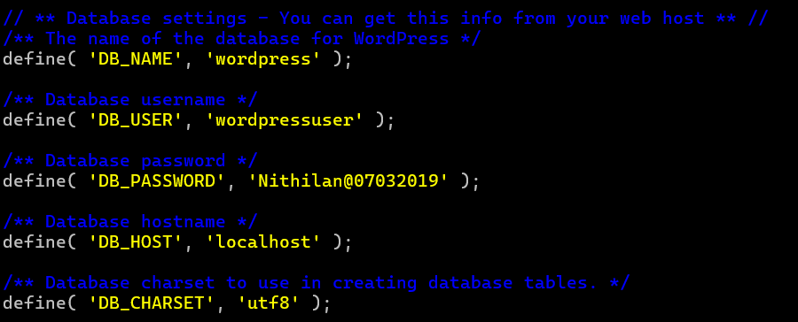

* + Update the database connection settings with the database name, username, and password you created earlier.

1. **Complete WordPress Installation:**

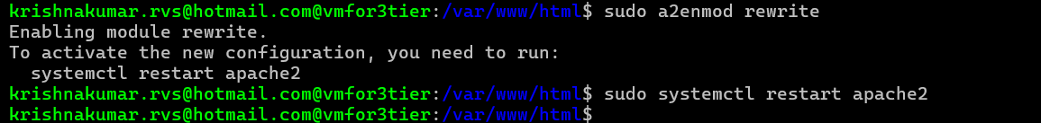Access your VM's public IP address or domain name in a web browser.

* + Follow the WordPress installation wizard to set up your site, including providing a site title, creating an admin user, and configuring other settings.

1. **Customize WordPress:**
   * Log in to the WordPress admin dashboard using the credentials you set during the installation.
   * Customize your WordPress site by installing themes and plugins, adding pages and posts, configuring settings, etc.
   * Install a custom theme or develop a custom theme using HTML, CSS, and PHP to match your desired design and functionality.
   * Customize the appearance and layout of your site by modifying theme files, adding custom CSS, and using WordPress's built-in customization options.
2. **Security and Performance Optimization:**
   * Implement security best practices such as using strong passwords, enabling SSL/TLS encryption, and securing your VM against unauthorized access.
   * Optimize your WordPress site for performance by enabling caching, compressing assets, and optimizing database queries.
   * Regularly update WordPress core, themes, and plugins to patch security vulnerabilities and improve performance.
3. **Backup and Monitoring:**
   * Set up regular backups of your WordPress site and database to protect against data loss.
   * Monitor your Ubuntu VM's performance and resource usage using Azure Monitor and other monitoring tools to ensure optimal performance and availability.

By following these steps, you can install WordPress on an Ubuntu-based Azure Virtual Machine and customize it according to your requirements. This approach gives you full control over your WordPress environment on an Ubuntu platform.